A Man & his Dog

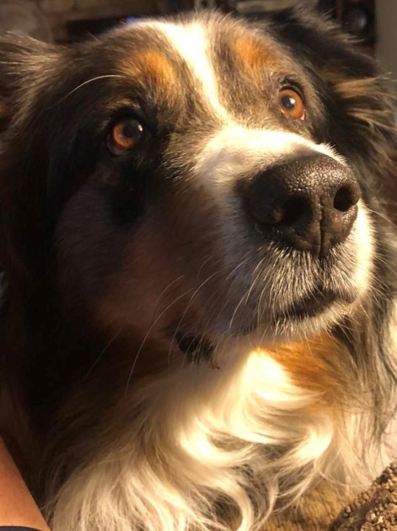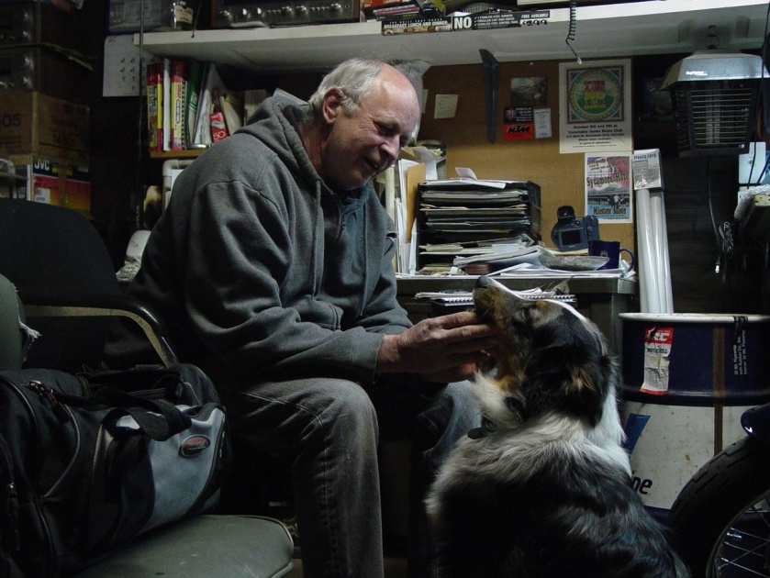

If you're lucky, I mean really lucky you just might find that special dog that might only come around once in a lifetime. For John, that dog was Flex. John & Flex had that special connection that we all hope to find in our companion. For John & Flex it wasn't just a physical bond it was very much mental as well. Flex knew what John was going to say before it was said. He also knew what John wanted him to do before he spoke a word. When Flex passed away John was devastated & heartbroken, which is understandable. There was a harsh & permanent void that we all will witness some day. At some point, through your grief, you have to accept that he is gone forever & that's the hardest part of losing a companion like Flex. Daily activities around the house only served to remind of Flex's presence at just about every turn. .John has 2 other Aussies that hopefully will keep him busy, but it will never be the same, but each relationship has a separate identity. Flex was aware that these guys were his replacement from day two. Yet he fostered their learning for me anyway. Flex was aware he was still top dog, he had privilege's they didn't. But for Flex, a whimper of love & affection, a cry out could always be heard if I was to show the others any love while in his presence.

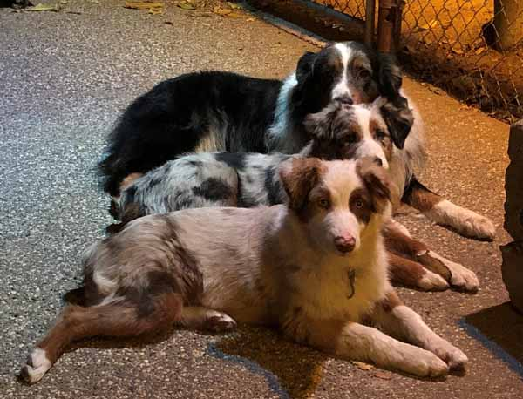

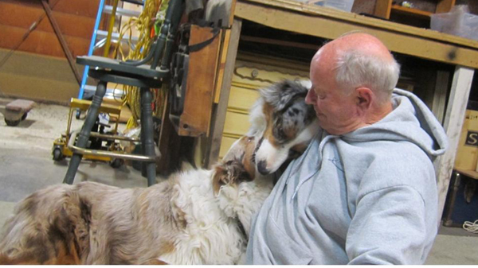

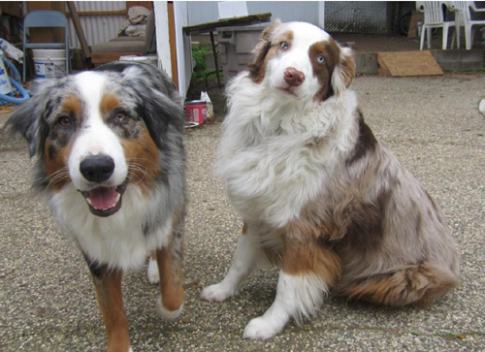

I say to all perspective owners, there will come a day, it's inevitable. Don't let that stop your dreams of an enriched life with a loving companion & such a profoundly insightful breed from coming true.

[Return to GA Aussies](GAaussies.htm)